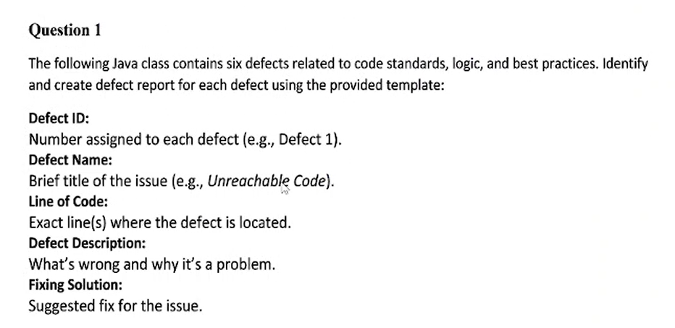
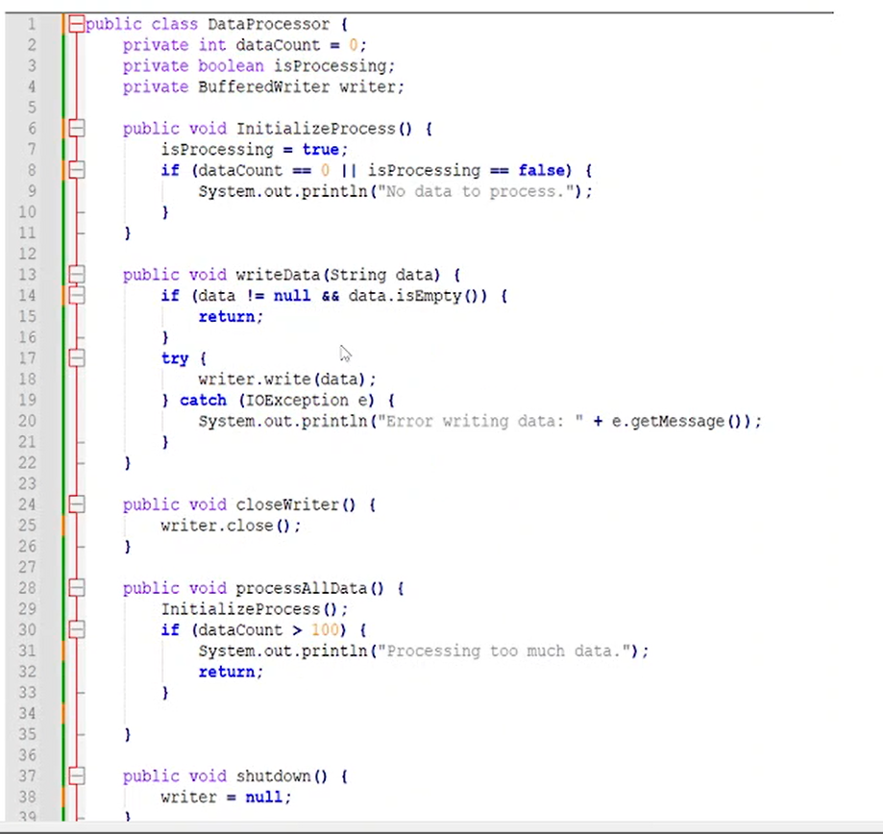

Defect ID: defect 1
Defect Name: invalid isProcessing logic
Line of Code: 8
Defect Description: isProcessing is set true before check in condition
Fixing solution: isProcessing = true move to end of function

Defect ID: defect 2
Defect Name: No check null for writer
Line of Code: 18
Defect Description: writer is null then write method can not be used ( it throw exception)
Fixing solution: isProcessing = true move to end of function

Defect ID: defect 3
Defect Name: No try catch when work with file
Line of Code: 25
Defect Description: an error syntax , when work with file
Fixing solution: use trycatch for writer.close()

Defect ID: defect 4
Defect Name: No try catch when work with file
Line of Code: 25
Defect Description: an error syntax , when work with file
Fixing solution: use trycatch for writer.close()

Defect ID: defect 5
Defect Name: not import IOexception
Line of Code:
Defect Description:
Fixing solution:

Defect ID: defect 6
Defect Name: datacount not change in processData
Line of Code: 41-44
Defect Description: if condition never true if data count not change
Fixing solution: add if (datacount <100 ) datacount ++;

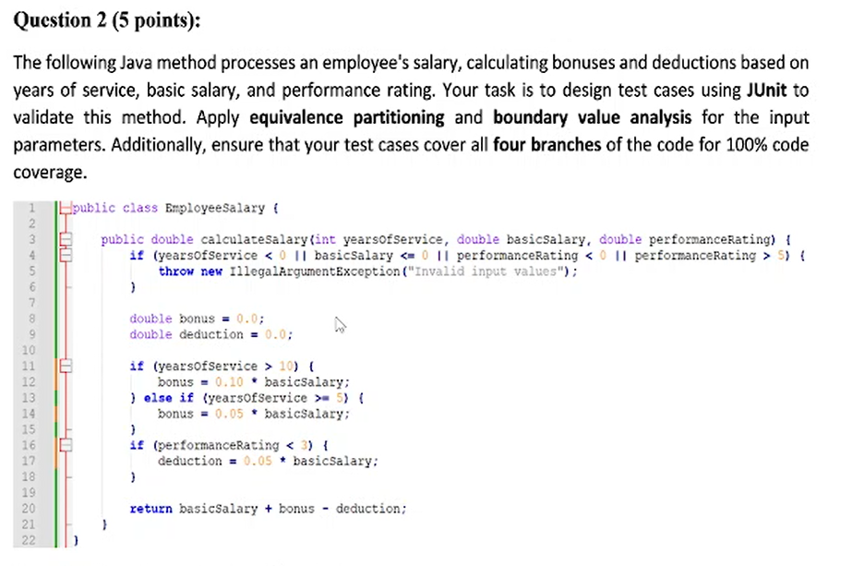
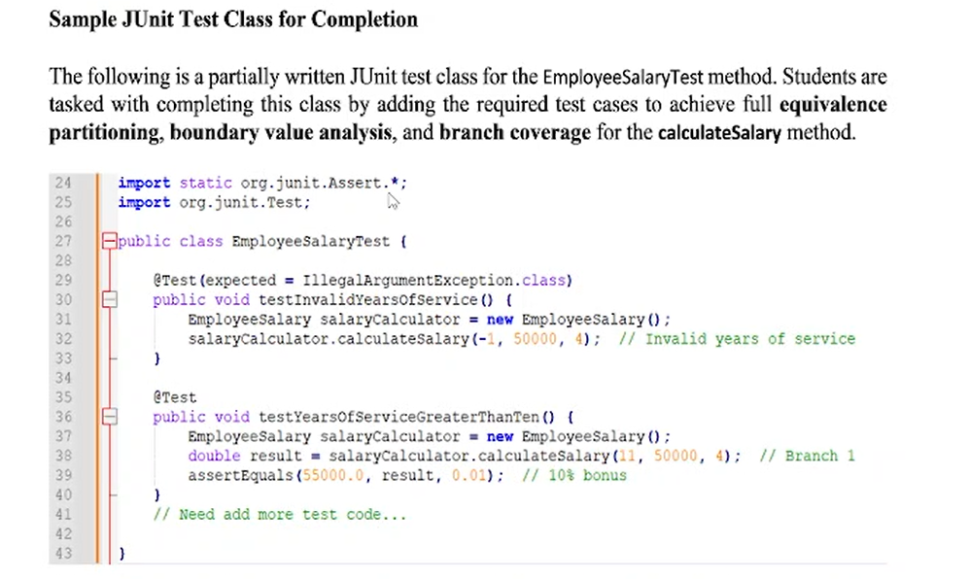

Q3:

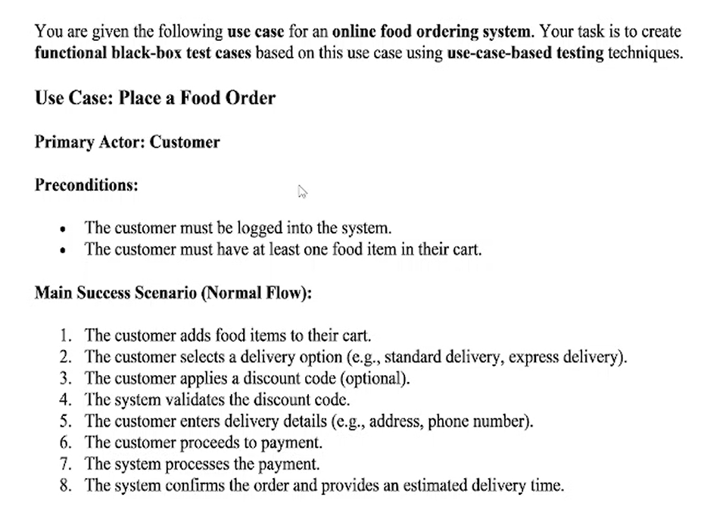
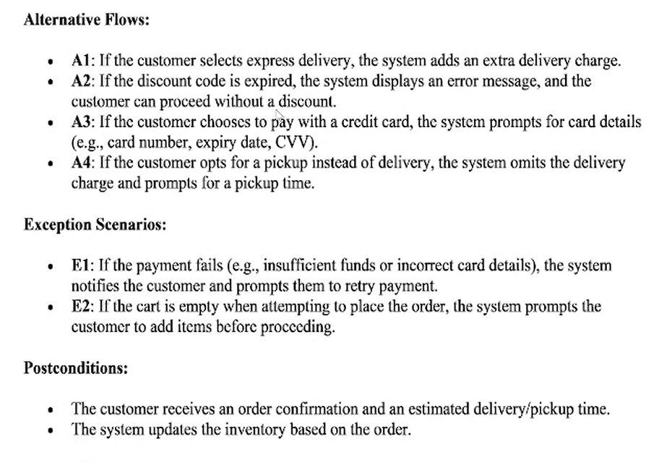
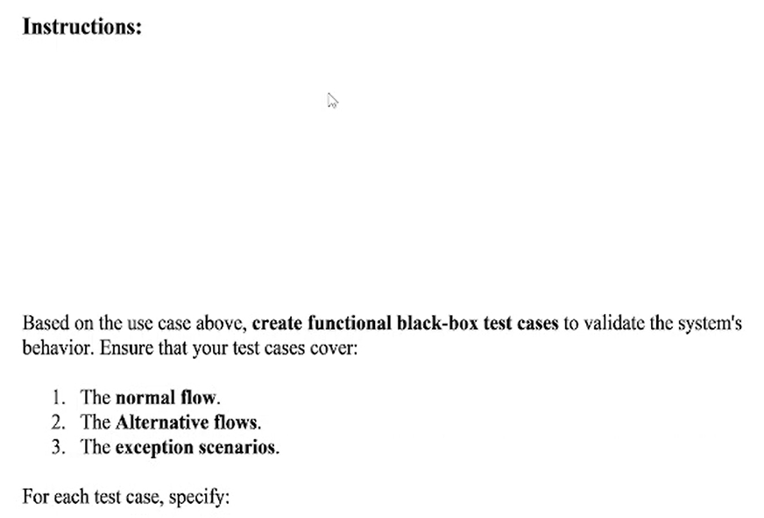
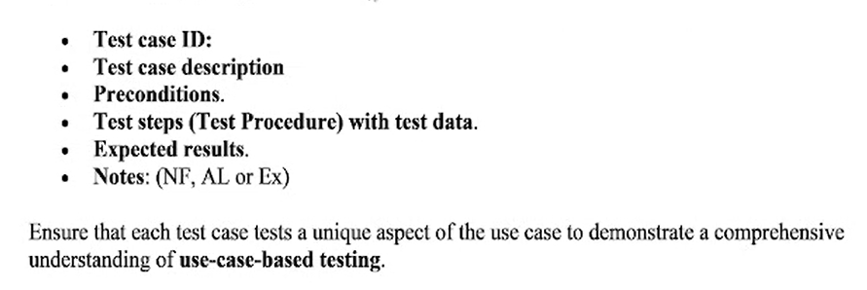
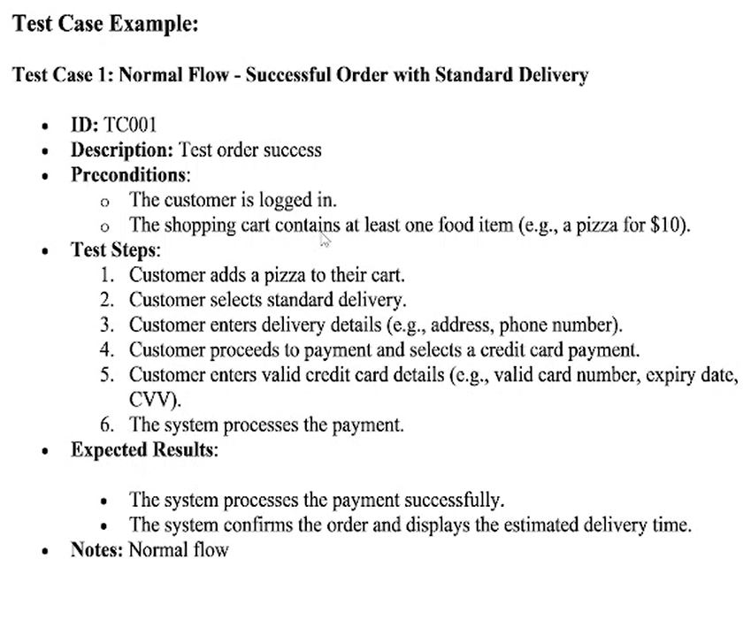

Test Case ID: 002
Desciption: Checking order succesflly in case delivery= Express delivery
Pre-condition:
+ User has log into the system successfully
+ Shoping cart has at least one item

Test Steps:s
1. The customer adds pizza to their cart.
2. The customer selects a fast delivery
3. The customer enters delivery details (e.g., address, phone number).
4. The customer proceeds to payment and select card payment
5. Customer fill the valid card detail
6. The system processes the payment.
Expected Result:
- The system processes the payment successfully and add extra fee.
- The system confirms the order and display delivery time
Note: alternative Flow

Test Case ID: 003
Desciption: Test order with discount expired
Pre-condition:
+ User has log into the system successfully
+ Shoping cart has at least one item

Test Steps:s
1. The customer adds pizza to their cart.
2. The customer selects a delivery (normal)
3. The customer applies a expired discount code.
4. The system validate the discount code
Expected Result:
- The system display an error message
- The customer proceed to fill in the delivery details without a discount
Note: alternative Flow

Test Case ID: 004
Desciption: Test order with discount expired
Pre-condition:
+ User has log into the system successfully
+ Shoping cart has at least one item

Test Steps:s
1. The customer adds pizza to their cart.
2. The customer selects a delivery (normal)
3. The customer applies a expired discount code.
4. The system validate the discount code
Expected Result:
- The system display an error message
- The customer proceed to fill in the delivery details without a discount
Note: alternative Flow

